**Supporting Information**

## Supplementary methods

**Method S1.** Detailed descriptions of the extraction methods for metallic elements, molecular methods, and statistical analyses.

**Extraction of available metal elements from soils**

Available potassium (AK), calcium (ACa), sodium (ANa), and magnesium (AMg) were extracted using 1 M ammonium acetate (CH3COONH4) at a soil to solution ratio of 1:10 from samples that were shaken for 30 min at 180 r min-1 and 20°C. Available iron (AFe), manganese (AMn), copper (ACu), and zinc (AZn) were extracted using diethylenetriamine pentaacetic acid at a soil to solution ratio of 1:2 from samples that were shaken for 2 h at 180 r min-1 and 25°C. The extracts were filtered through qualitative filter paper and analyzed using a flame photometer (Philes, Nanjing, China).

**Construction of*****F. oxysporum* plasmids and quantitative PCR**

Construction of *F. oxysporum* plasmids. Each 20 µL PCR reaction system contained 10 μL of 2× Premix Taq™ (TaKaRa Bio Inc., Kusatsu, Shiga, Japan), 0.5 μL of each forward and reverse primer (10 μmol L-1 each), 7 μL of sterile ddH2O, and 2 μL of soil DNA (ranging in concentration from 35.6 to 347.2 ng μL-1). Thermal cycling was performed using an A300 Fast Thermal Cycler (LongGene) under the following amplification conditions: an initial denaturation at 95°C for 2 min, followed by 40 cycles of 94°C for 30 s, 58°C for 15 s, and 72°C for 15 s. The yield and quality of the amplicons were assessed by gel electrophoresis, and the better-quality products were selected for recycling (Tanon EPS 200, China). Finally, *F. oxysporum* plasmids were prepared by cloning and transformation, and stored at -80°C until used for absolute quantitation.

Quantitative PCR of specific steps. The 10 μL reaction systems contained 5 μL of 2× SYBR Green premix Ex Taq (TaKaRa, Dalian, China), 0.25 μL each of forward and reverse primers (10 μmol L-1 each), 6 μL of sterile ddH2O, and 2 μL of soil DNA (ranging in concentration from 35.6 to 347.2 ng μL-1). *F. oxysporum* DNA was quantified using the primer pair Fon-1/Fon-2 (5′-CGATTAGCGAAGACATTCACAAGACT-3′ and 5′-ACGGTCAAGAAGATGCAGGGTAAAGGT-3′). Thermal cycling was conducted at 95°C for 2 min, followed by 40 amplification cycles at 94°C for 30 s, 58°C for 15 s, and 72°C for 15 s. Fluorescence values were determined at the DNA refolding and elongation in each cycle. To evaluate the amplification specificity, melting curve analysis was conducted after each SYBR Green PCR run. The standard curves were fixed according to the method described by López-Mondéjar et al. (2010).

**References**

Barberan, A., Bates S.T., Casamayor, E.O., Fierer, N., 2012. Using network analysis to explore co-occurrence patterns in soil microbial communities. ISME Journal. 6(2), 343-351. 10.1038/ismej.2011.119

Benjamini, Y., Hochberg, Y., 1995. Controlling the false discovery rate - a practical and powerful approach to multiple testing. Royal Statistical Society. 57, 289–300. 10.1111/j.2517-6161.1995.tb020 31.x

Lopez-Mondejar, R., Antón, A., Raidl, S., Ros, M., Pascual, J.A., 2010. Quantification of the biocontrol agent Trichoderma harzianum with real-time TaqMan PCR and its potential extrapolation to the hyphal biomass. Bioresource Technology, 101(8), 2888-2891. 10.1016/j.biortech.2009.10.019.

**Table** **S1** The basic soil fertility of the 0-20 cm plow layer before the consecutive watermelon cultivation experiment. SOM: Soil organic matter, TN: Total nitrogen, TP: Total phosphorus, TK: Total potassium. AN: Available nitrogen, AP: Available phosphorus, AK: available potassium. EC: soil electrical conductivity.

|  |  |  |  |  |  |  |  |
| --- | --- | --- | --- | --- | --- | --- | --- |
|  | SOM  (g/kg) | TN  (g/kg) | TP  (g/kg) | TK  (g/kg) | AN  (mg/kg) | AP  (mg/kg) | AK  (mg/kg) |
| Soil | 16.00 | 17.30 | 1.60 | 1.50 | 107.41 | 31.74 | 80.0 |

|  |  |  |  |  |
| --- | --- | --- | --- | --- |
|  | pH | EC  (ms/cm) | bulk density  (g/cm) | moisture content  (%) |
| Soil | 6.92 | 0.19 | 1.43 | 25.22 |

**Table** **S2** Watermelon yield under different fertilization treatments from 2014 to 2021. No data were collected in 2020 due to the COVID-19 pandemic. Lowercase letters (a-g; *p* < 0.05) indicate year differences, and uppercase letters (A, B; *p* < 0.05) indicate fertilizer differences.

|  |  |  |
| --- | --- | --- |
| Year | CF  kg/field | MF  kg/field |
| 2014 | 87.5±2.2 aA | 76.1±6.1 aB |
| 2015 | 69.6±5.9 bA | 67.8±3.3 bA |
| 2016 | 48.7±10.6 cA | 43.5±8.5 cA |
| 2017 | 33.6±1.2 dA | 34.4±3.8 dA |
| 2018 | 0±0 gA | 0±0 gA |
| 2019 | 5.4±2.5 fB | 11.7±2.6 fA |
| 2021 | 8.4±1.2 eB | 28.5±3.7 gA |

**Table** **S8** Multiple linear regression analysis showed the effects of soil nutrient characteristics, microbial nutrition strategies, key microbial communities, and their potential functions on watermelon quality and yield. Multiple R-squared: 0.621, Adjusted R-squared: 0.613, *p*-value: 0.000.

|  |  |  |  |  |
| --- | --- | --- | --- | --- |
| Compound variables |  | t-value | Estimate | *p-*value |
| Soil Nutrient  Cycling | SC | 5.206 | 0.530 | 0.000 |
| SN | 5.468 | 0.571 | 0.000 |
| SP | -1.760 | -0.191 | 0.085 |
| Microbial Nutrition Strategy | RRN | 5.622 | 0.772 | 0.000 |
| BKR | 0.716 | 0.106 | 0.478 |
| FKR | -4.358 | -0.520 | 0.000 |
| Essential microbes | FON | -0.914 | -0.109 | 0.366 |
| PRPB | 2.690 | 0.299 | 0.010 |
| PCGM | 5.751 | 0.636 | 0.000 |
| NCGM | -0.115 | -0.015 | 0.908 |
| Potential Microbial Functions | MC | 5.434 | 0.728 | 0.000 |
| MN | -1.870 | -0.204 | 0.068 |
| MP | 0.477 | 0.066 | 0.636 |

Fig. S1 The occurrence of watermelon wilt disease from 2014 to 2021 is described. Notably, in 2018, the disease was most severe, leading to complete plant wilting and no watermelon yield. No data were collected in 2020 due to the COVID-19 pandemic.

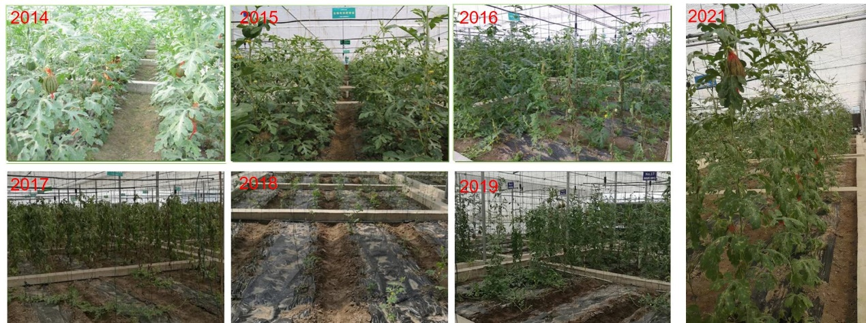

Fig. S2 Nutrient contents of soil (a-l) at different growth stages under different fertilization treatments. Uppercase letters (A, B, C, D; *p* < 0.05) indicate growth time differences, and lowercase letters (a, b; p < 0.05) indicate fertilizer differences.

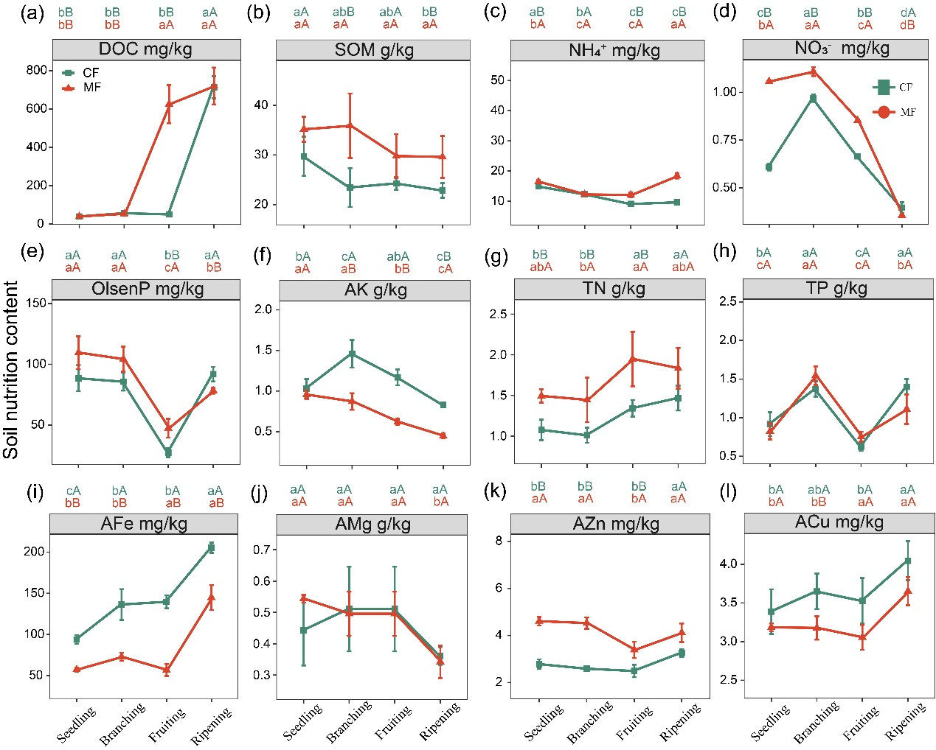

Fig. S3 Differences in sweetness (a-b), weight (c), plant biomass (d-f), and fruit nutrient content (g-i) of watermelon under various fertilization treatments. The radar chart area method showing changes of the quality index of watermelon plants under different fertilizer treatments (j). Watermelon plant quality (k) and yield (l) under different fertilization treatments. *: *p* < 0.05, **: *p* < 0.01, ***: *p* < 0.001.

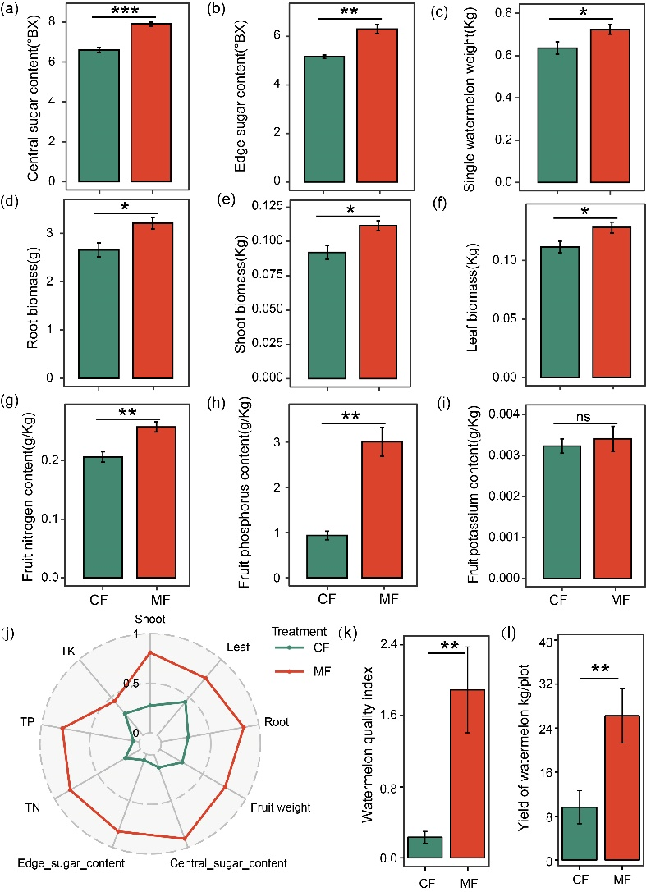

Fig. S4 Nutrient contents of roots (a), shoot (b) and leaves (c) at different growth stages under different fertilization treatments. Uppercase letters (A, B, C, D; *p* < 0.05) indicate growth time differences, and lowercase letters (a, b; p < 0.05) indicate fertilizer differences.

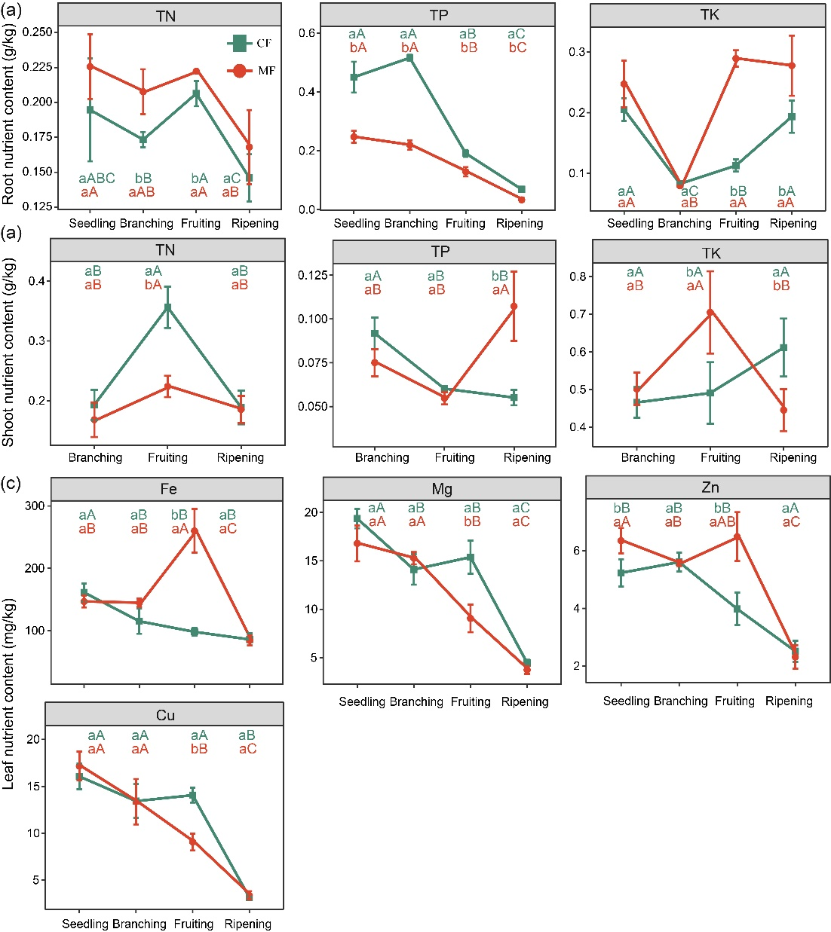

Fig. S5 Alpha diversities diversity of bacterial (a) and fungal (b) communities in the soil-plant continuum under different fertilization conditions and growth periods. *: *p* < 0.05, **: *p* < 0.01. Structure of bacterial (c) and fungal (d) microbial communities in each niche (rhizosphere, roots, stems, leaves) under different fertilization treatments.

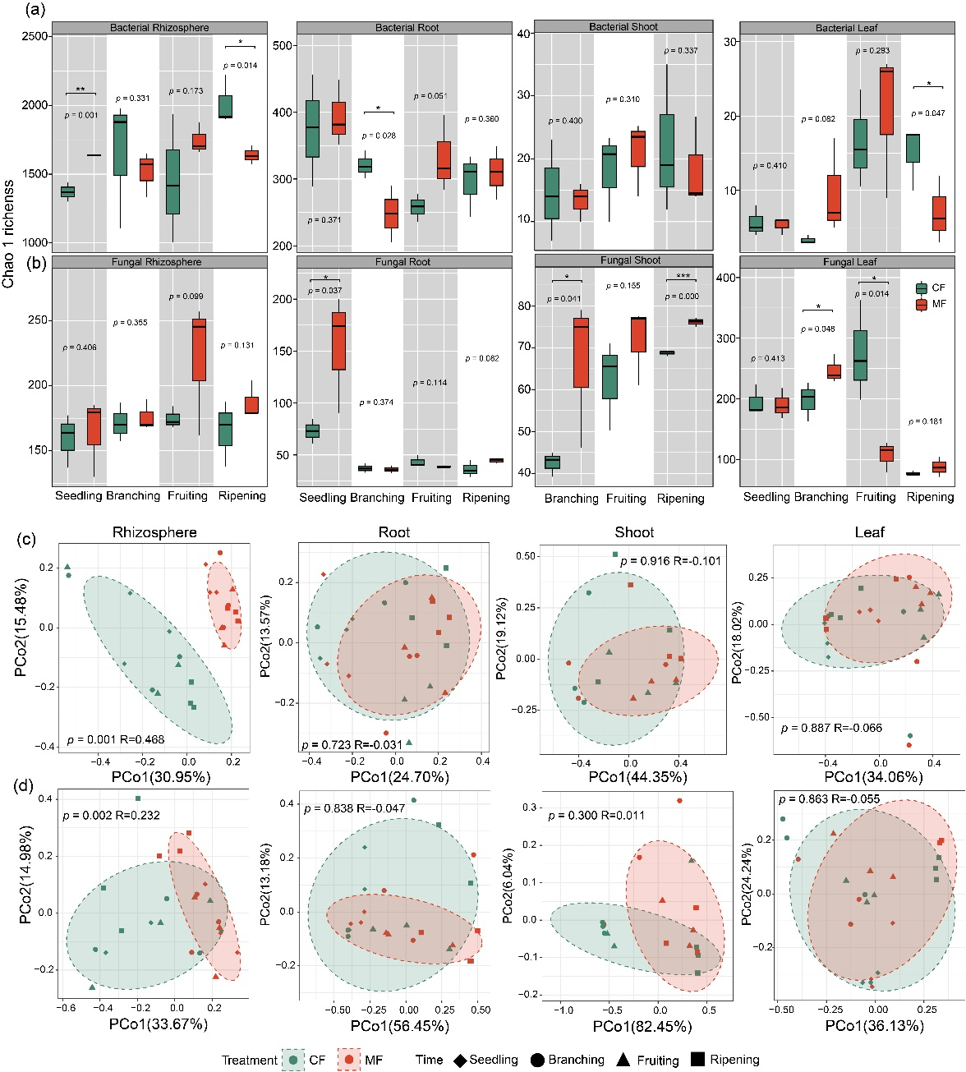

Fig. S6 Community composition of bacterial (a) and fungal (b) communities at the genue level in the soil-plant continuum under different fertilization conditions and growth periods.

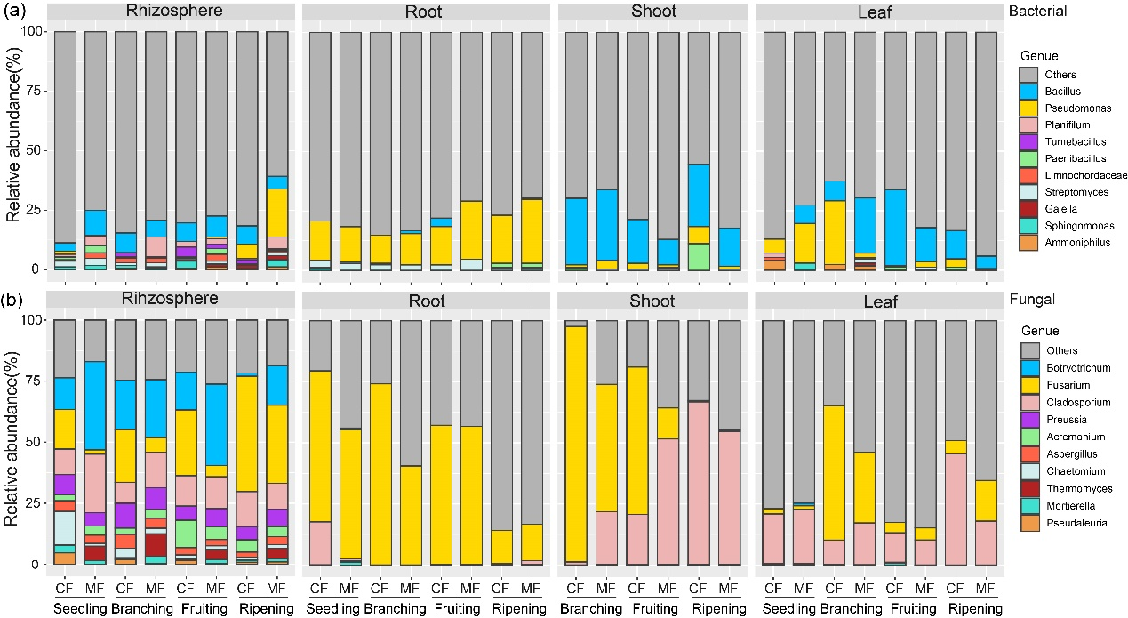

Fig. S7 The neutral model (NCM) fitting of bacterial communities inhabiting in different root-associated microhabitats. The solid blue lines indicated the best fit to the NCM and the dashed blue lines represent 95% confidence intervals around the model prediction. ASVs that occur more or less frequently than predicted by the NCM are shown in different colors. Nm indicates the metacommunity size times immigration, R2 indicates the fit to this model.

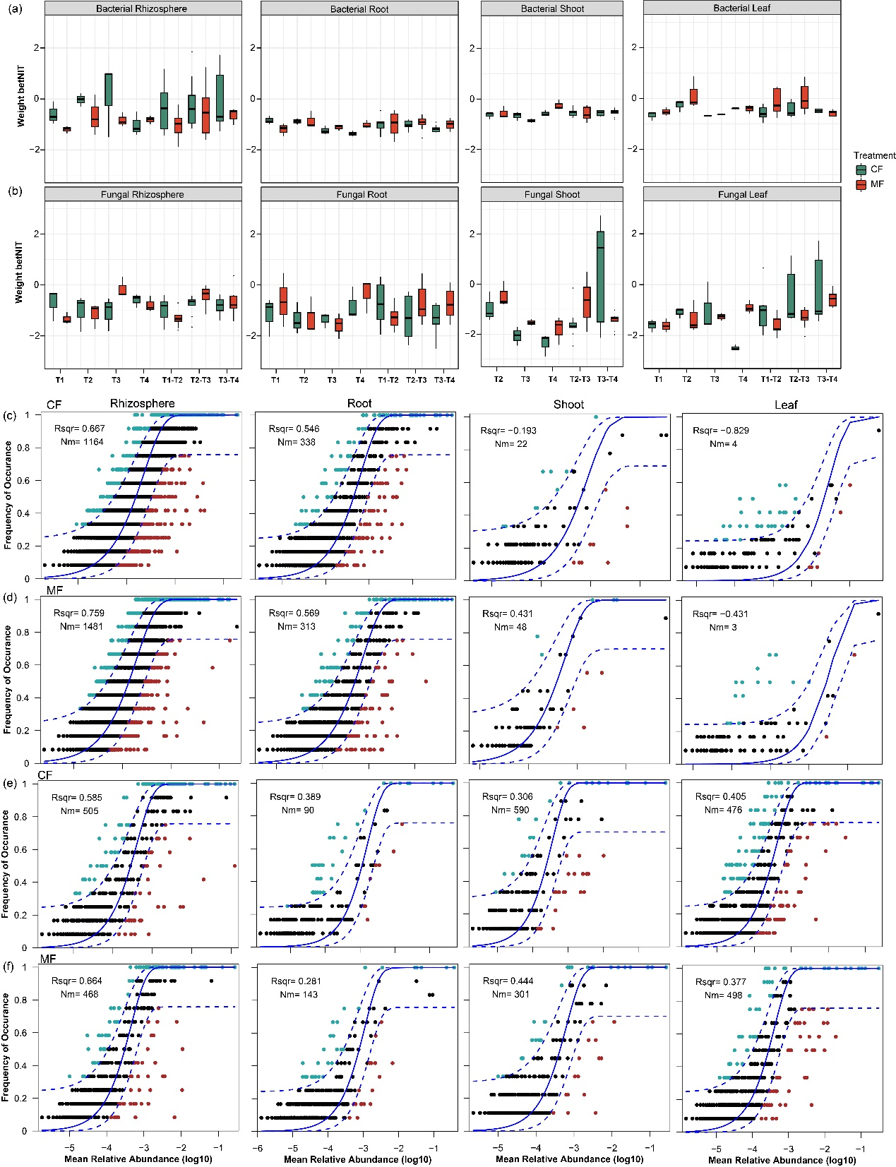

Fig. S8 Significant Spearman correlations (p < 0.05) were found between organism groups (including microbial community structure, plant growth-promoting bacteria along the soil-plant continuum, ribosomal copy number, and Fusarium verticillioides) and weighted multifunctionality and individual ecosystem functions (including carbon, nitrogen, phosphorus, metal nutrients, and productivity). The white box represents *p* > 0.05, while the other colors indicate *p* < 0.05.

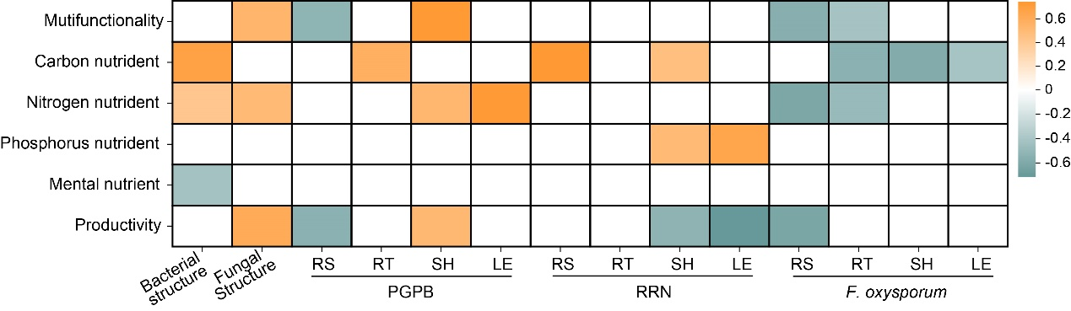

Fig. S9 Functional and correlational analysis of bacterial cycling of carbon, nitrogen, and phosphorus in rhizosphere soil across fertilization treatments and growth stages. The inner ring heatmap represents the functional abundance of carbon, nitrogen, and phosphorus cycling of bacteria in rhizosphere soil under various fertilization treatments and growth stages. The outer ring heatmap shows the correlation between the abundance of bacterial C, N, and P cycling functions and microorganisms (*Fusarium oxysporum*, relative abundance of plant growth promoting bacteria and soil ribophorae longitudinal copy number) in rhizosphere soil under various fertilization treatments and growth stages. URE: ureolysis, MT: methanotrophy, NITR: nitrogen respiration, NR: nitrate respiration, MTO: methylotrophy, MO: methanol oxidation, RA: reductive acetogenesis, TCS: two-component system, NF: nitrogen fixation, HD: hydrocarbon degradation, ANMHC_D: aliphatic non methane hydrocarbon degradation, PPM: Phosphonate and phosphinate metabolism, NPC: nonphotosynthetic cyanobacteria, PYM: Pyrimidine metabolism, PM: Purine metabolism, OXPHOS: Oxidative phosphorylation, PPP: Pentose phosphate pathway, NIT: nitrification, ANO: aerobic nitrite oxidation, AAO: aerobic ammonia oxidation, NIR: nitrite respiration, NRD: nitrate reduction, CLY: chitinolysis, PYR-M: Pyruvate metabolism, AHD: aromatic hydrocarbon degradation, CH: chemoheterotrophy, ACD: aromatic compound degradation, DHO: dark hydrogen xidation, XYL: xylanolysis, CL: cellulolysis, PTS: Phosphotransferase system, FERM: fermentation, FR: fumarate respiration.

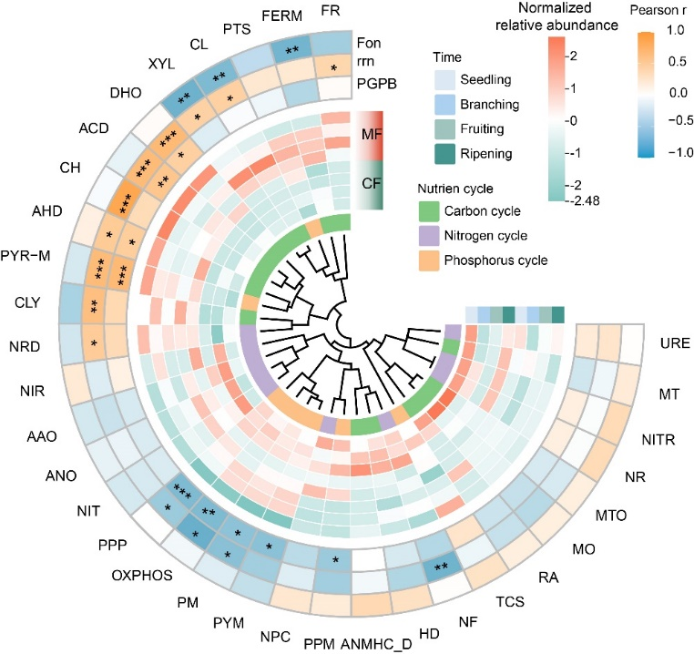

Fig. S10 Generalist microbial community composition of bacteria (a) and fungi (b) at the phylum level in the soil-plant continuum under different fertilization conditions and growth periods.

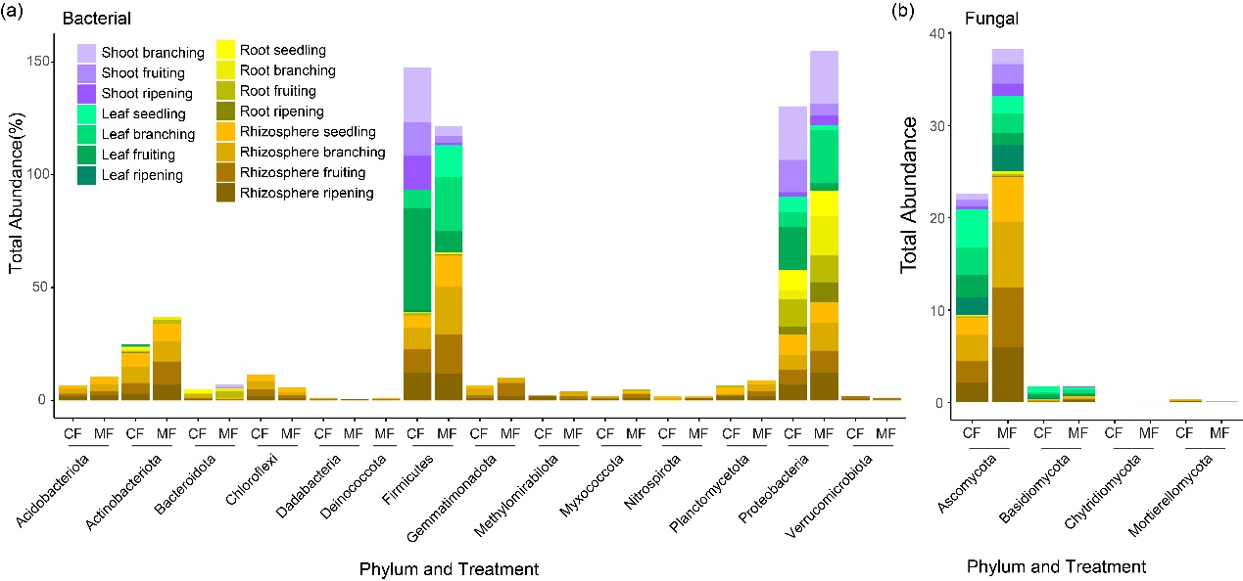

Fig. S11 The relative abundance of bacterial core generalist microbes in the soil-plant continuum under different fertilization conditions and growth periods. Uppercase letters (A, B, C, D; *p* < 0.05) indicate growth time differences, and lowercase letters (a, b; p < 0.05) indicate fertilizer differences.

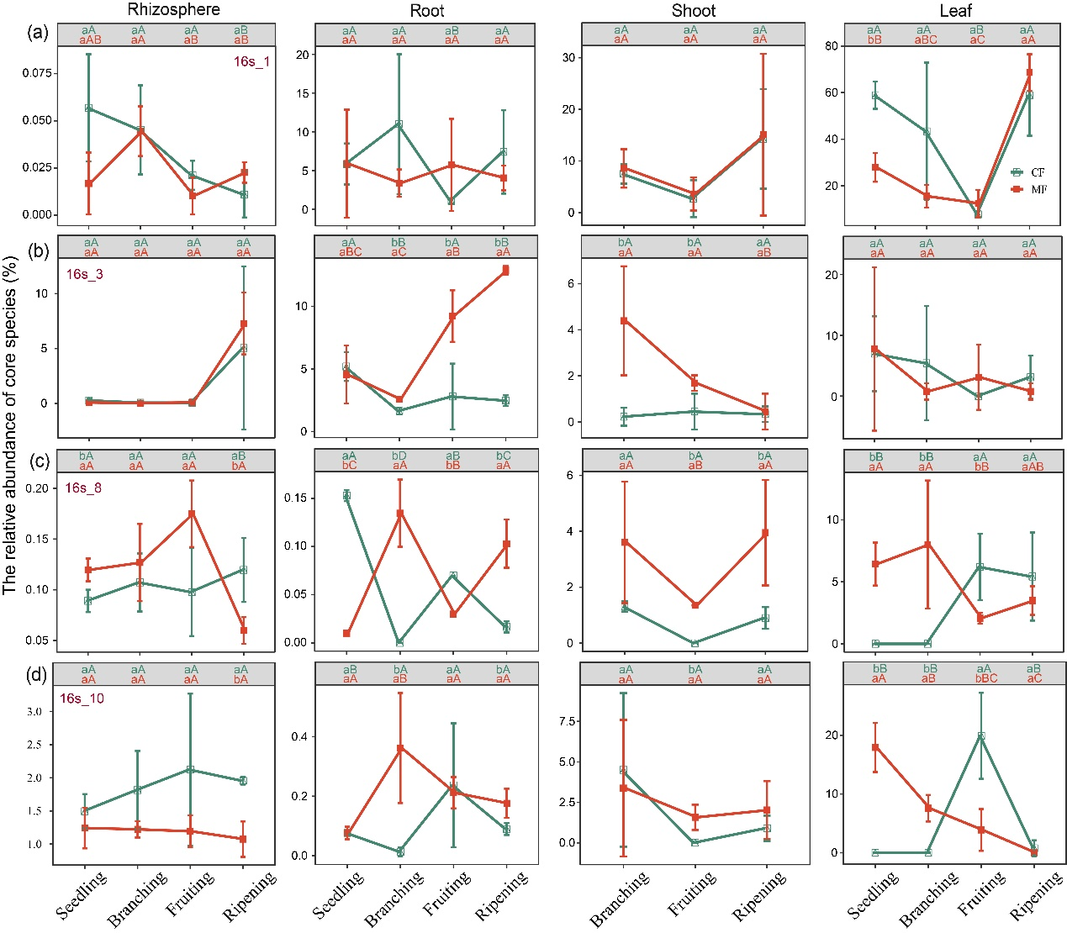

Fig. S12 the relative abundance of fungal core generalist microbes in the soil-plant continuum under different fertilization conditions and growth periods. Uppercase letters (A, B, C, D; *p* < 0.05) indicate growth time differences, and lowercase letters (a, b; p < 0.05) indicate fertilizer differences.

